**OPIM 5604**

**Predictive Modeling Preprocessing Project 1**

**Team 5: Barcelona Airbnb**

**Team Members:**

Likhitha Guggilla, Mrugal Pramod Nikhar, Pawan Manikanta Reddy Pamireddy, Sai Krishna Rangabashyam Gomathi, Biao Wang, Alison Wenman

**2. Table of Contents**

**1**. **Front Cover……………………………………………………..**1

**2**. **Table of Contents………………………………………………**2

**3**. **Columns Documentation………………………………………**3-14

**4**. **Data Preprocessing**……………………………………………..15

1. *Hide and Exclude* ……………………………………………16
2. *Binning Indicator Columns, and Recode*……………………17-20
3. *Missing Values*……………………………………………….20,21
4. *Outliers*………………………………………………………21-23
5. *Reducing Dimensionality…………………………………………*24

**5**. **Conclusion**………………………………………………………25

**3. Column Summary**

In project 1, our location was in Barcelona, Spain. We had to clean, remove, and modify the data through the SEMMA process. We had the initial sample with 75 columns and 17,231 rows. We explored and determined which columns were necessary in our analysis based on missing values, correlations, what type of variables (nominal, ordinal, continuous) they were and if they would be a good predictor for our target variable, price. We modified some of the columns to show numerical values to make them continuous that we marked down in the column summary table down below. After all the data was preprocessed we modeled the cleaned data to see what would have an impact on price as well as looking at the different correlations between each variable presented in the data. After exploring the models we assessed which variables would have the strongest impact on price through different analyses we performed throughout the project. Below are all of our findings.

We went through each column documenting what columns were included or not and why due to the impact on the predictor variable, price.

*Table 1: Column Summary*

| **Col No.** | **Column name** | **Activity Chosen** | **Column Description and Reason** |
| --- | --- | --- | --- |
| 1 | ID | Hide and Exclude | This has been disincluded from the dataset because it has no impact on price. The ID is the number given to each row and it is unique to each airbnb listing. While it is a numerical column it is just the unique identifier. |
| 2 | Listing_url | Hide and Exclude | The URL has been disincluded from the dataset. The url is a hyperlink to the listing for the airbnb and has no direct impact because it leads to a unique link of the listing. |
| 3 | Scrape_id | Hide and Exclude | The Scrape ID has been disincluded from the dataset. The scrape ID identifies when the data was extracted from the internet which would have zero impact on the price. It also has zero impact on the other columns therefore it is irrelevant. |

| 4 | Last_scraped | Hide and Exclude | The last Scraped has been disincluded from the dataset. The scrape ID identifies when the data was last extracted from the internet which would have zero impact on the price. It also has zero impact on the other columns therefore it is irrelevant. |
| --- | --- | --- | --- |
| 5 | Source | Hide and Exclude | The source has been disincluded from the dataset. There were two options for the source where the data was extracted from: city or previous scrape. This would have no impact on price because this correlates to how the data was extracted on the internet. |
| 6 | Name | Include | The name represents the type of airbnb in barcelona. It describes how many bedrooms, bathrooms, and baths there are. While it is a description and has no direct impact on price, we want to include this in dataset and modify it to extract the number of bedrooms into a new column. |
| 7 | Description | Hide and Exclude | The description describes where the listing is located as well as an introduction into the surrounding areas. There was no data to extract from this therefore we do not need to include it because there will be no correlations between the description and price. |
| 8 | Neighborhood  _overview | Hide and Exclude | The neighborhood overview describes what the surrounding areas are and what some different activities are in the close by neighborhoods. While this may be a good description, there can be no data extracted for this column therefore we have decided to exclude it from the dataset. |
| 9 | Picture_url | Hide and Exclude | The picture URL is a link to see what each individual apartment looks like. While this (in theory) could be a good indicator for potential prospects to see what they are booking, there can be no sufficient data extracted from it so it is excluded from the dataset. |
| 10 | Host_id | Hide and Exclude | The host_id is a unique identifier for the host who is in charge of the rental unit. This was not included in the dataset because the ID is not correlated to anything in the dataset except for indicating the host therefore it will not have an impact on price. |
| 11 | Host_url | Hide and Exclude | The host_url is a link to the host for the different units. While it has a description of who they are, it does not have an impact on the price so it will be excluded from the dataset for insufficient data. |

| 12 | Host_name | Hide and Exclude | The host name describes the host name of the unit. There would be no correlation between a name and price of the listing therefore it has been excluded from the dataset. There was also no way to extract any data to have reasonable assumptions made. |
| --- | --- | --- | --- |
| 13 | host_since | Hide and Exclude | The host_since describes how long the host has been a host on airbnb renting that unit. This could have some importance but we have decided to exclude it from the dataset because it wouldn’t matter if the host had been a host for a year or 10 years all that much to have a significant impact on price. |
| 14 | host_location | Hide and Exclude | The host_location describes where in Spain the host is located. Since the location of the host does not have an impact on the location of the unit it will not have an impact on price therefore we have decided to exclude it from our dataset. |
| 15 | host_about | Hide and Exclude | The host_about is a description of who the host is. While this may be good information to have so that the person who looks at the listing has an idea of who the hosts are, there won't be any sufficient data to pull from there that would be a good predictor of price so we excluded it from the dataset. |
| 16 | host_response_ti me | Include | The host response time is how responsive the host is after receiving a message from the prospect about the rental unit. This could influence the target variable. It has been analyzed that having a lesser response time would have a higher mean price in most of the neighborhood. |
| 17 | host_response_r ate | Hide and Exclude | The host response rate is how often the host responds to a message. We have chosen to exclude it because it could have an impact on price. |
| 18 | host_acceptance  _rate | Hide and Exclude | The host acceptance rate is how often the host accepts new prospects/customers to rent the airbnb. We have chosen to exclude it from our dataset due 3000 missing records and a high number or high acceptance rate therefore it would not have a significant impact on predicting the price. |

| 19 | host_is_superho st | Hide and Exclude | The host is superhost is an indicator column of either “T” or “F” which indicates true or false. This means whether the host is the “owner” of the unit. This will not have a sufficient amount of data to support whether this has an impact on price therefore we did not include this in our dataset. |
| --- | --- | --- | --- |
| 20 | host_thumbnail_ url | Hide and Exclude | The host thumbnail url is a link to show the picture or thumbnail” of the hosts. There is no data correlated with this therefore we cannot have this as a supportive column for predicting the price so we excluded it from our dataset. |
| 21 | host_picture_url | Hide and Exclude | The host picture url is a link to show the picture of the hosts. There is no data correlated with this therefore we cannot have this as a supportive column for predicting the price so we excluded it from our dataset. |
| 22 | host_neigbourho od | Hide and Exclude | The host neighborhood documents what neighborhood the listing is in. There is not sufficient information to see whether there will be an impact on price therefore we excluded it from our dataset. |
| 23 | host_listings_co unt | Hide and Exclude | The host listing count is the number of listings that each unique host has in spain. The count of these listings would not have a direct impact on the single price of a unit therefore we have excluded it from our dataset. |
| 24 | host_total_listin gs_count | Hide and Exclude | The total listings count is the sum of all of the listings that each unique host in spain. The count of these listings would not have a direct impact on the single price of a unit therefore we have excluded it from our dataset. |
| 25 | host_verificatio ns | Hide and Exclude | The host verifications are the platform that they use to message their potential customers on. The platform would not indicate a difference in price therefore we can exclude it in our dataset. |

| 26 | host_has_profile  _pic | Hide and Exclude | Host has a profile pic indicating whether the host has a picture attached to their airbnb profile. This is coded as either a “T” or “F” indicating true or false. The picture has no sufficient data to predict the price therefore we have excluded it from the dataset. |
| --- | --- | --- | --- |
| 27 | host_identity_ve rified | Include | The host identity verified is whether the host has been accurately verified. This can have an impact on price. For instance if a host who is verified in the same location, same amenities, there could be an impact if there is a host who is not verified. Some people may be inclined to pay more for someone who is verified versus not verified. |
| 28 | neighborhood | Hide and Exclude | The neighborhood is describing which neighborhood the unit is a part of. This is a generalized value (Barcelona) so it is not sufficient data to be extracted that would be a good predictor for price so we excluded it from our dataset. |
| 29 | neighbourhood_ cleansed | Include | The neighborhood cleansed is describing which neighborhood the unit is a part of. For different locations there might be differentiations in pricing therefore it could be a good variable for predicting price. |
| 30 | neighbourhood_ group_cleansed | Hide and Exclude | The neighborhood group cleansed is describing which neighborhood the unit is a part of. There is not sufficient data to be extracted as well as it is the same as neighborhood cleansed therefore we excluded it from our dataset due to redundancy. |
| 31 | Latitude | Hide and Exclude | Latitude is the coordinates where the listing is located. Based on the lack of sufficient data that can be extracted from the variable to be a good predictor of price we have decided to exclude it from our dataset. |
| 32 | Longitude | Hide and Exclude | Longitude is the coordinates where the listing is located. Based on the lack of sufficient data that can be extracted from the variable to be a good predictor of price we have decided to exclude it from our dataset. |

| 33 | property_type | Hide and Exclude | Property type is the type for the listing (private room in rental unit, entire home, etc). Property type is very similar to the room type so we would have redundant information therefore we excluded it from our final dataset. |
| --- | --- | --- | --- |
| 34 | room_type | Include | The room type is defined as what rooms are available for each unique listing. They can be a private room or the entire house/apartment. Because of the different sizes and what is offered at each room, this could be a good predictor in the amount for each unit rented therefore we have included it in our dataset. |
| 35 | accommodates | Include | Accommodates are the total amount of people who can be at each rental unit per booking. Because this counts for the total number of people (some with higher amounts or lower amounts) this could have an impact on the price, so we have decided to include this in our dataset. |
| 36 | bathrooms | Hide and Exclude | Bathrooms is the total count of all the bathrooms that are included in the unit. There is no data so we cannot use any information for the predictor variable, therefore we excluded it from our dataset. |
| 37 | bathroom_texts | Include | The bathroom texts are the type of bathrooms and the count associated in the unit (shared, bath, baths). Since we want to extract bathroom count from this column it is included in the data set |
| 38 | bedrooms | Hide and Exclude | The bedrooms are the total number of bedrooms for each individual unit. There are 5894 missing records therefore we excluded it from our dataset. Bedrooms could be a good predictor of price, so we extracted the count of bedrooms from the name column. |

| 39 | beds | Include | Beds is the total number of beds in each individual unit. Because the number of beds ranges for each unit that could have an impact on the price. For instance if the number of beds is higher that could indicate a higher price and vice versa so we have decided to include it in our dataset. |
| --- | --- | --- | --- |
| 40 | amenities | Include | The amenities are all the items such as kitchen, wifi, parking, etc that are included in each individual unit. This column would be a good predictor of price therefore we decided to modify and include it in our dataset.We have modified the data and grouped some items together. For modifying it we created a formula where if the unit has the item it labels it as a yes (1) or no (0). We have excluded some amenities items but have included tv, stove, refrigerator, kitchen, oven, wifi, parking, personal hygiene, essentials and clothing storage. |
| 41 | price | Include | The price determines the amount per unique listing in Spain. Since this is our predictor variable, in order to determine if the columns that we selected can be a good predictor we need to keep this in our dataset. |
| 42 | minimum_night s | Hide and Exclude | Minimum nights is defined as the minimum number of nights that a booking for each individual unit allows. For example if the unit has “4” listed that means that the customers who booked that listing have to stay there for a minimum of 4 days. We have decided to exclude this from our dataset as there was no substantial evidence that it would be a good predictor of price. |
| 43 | maximum_night s | Hide and Exclude | The maximum nights is defined as the maximum number of nights that a booking for each individual unit allows. For example if the unit has “30” listed that means that the customers who booked that listing have to stay there for a maximum of 30 days. We have decided to exclude this from our dataset as there was no substantial evidence that it would be a good predictor of price. |
| 44 | minimum_mini mum_nights | Hide and Exclude | The minimum minimum nights refers to the lowest minimum night value from the calendar for 365 days in the future. The lowest value for the minimum nights would not have an impact on the price because it is looking at the lowest minimum value therefore we have excluded it from our dataset. |
| 45 | maximum_mini mum_nights | Hide and Exclude | The maximum minimum nights refers to the highest minimum night value from the calendar for 365 days in the future. The highest value for the minimum nights would not have an impact on the price because it is just looking at the highest minimum value therefore we have excluded it from our dataset. |
| 46 | minimum_maxi mum_nights | Hide and Exclude | The minimum maximum nights refers to the lowest maximum night value from the calendar for 365 days in the future. The lowest value for the maximum nights would not have an impact on the price because it is just looking at the lowest maximum value therefore we have excluded it from our dataset. |

| 47 | maximum_maxi mum_nights | Hide and Exclude | The maximum maximum nights refers to the highest maximum night value from the calendar for 365 days in the future. The highest value for the maximum nights would not have an impact on the price because it is just looking at the highest maximum value therefore we have excluded it from our dataset. |
| --- | --- | --- | --- |
| 48 | minimum_night s_avg_ntm | Hide and Exclude | The minimum nights average ntm refers to the average minimum_night value from the calendar for 356 in the future from when the customer selects it on the calendar. The average for the minimum nights would not have a substantial impact on price therefore we excluded it from the dataset. |
| 49 | maximum_night s_avg_ntm | Hide and Exclude | The maximum nights average ntm refers to the average maximum_night value from the calendar for 365 nights in the future from when the customer selects it on the calendar. The average for the maximum nights would not have a substantial impact on price therefore we excluded it from the dataset. |
| 50 | calendar_update d | Hide and Exclude | Calendar updated refers to if the host has their calendar updated on the listing. Although this might’ve been a good column to predict price there was no information in this column therefore we have to exclude it from our dataset. |
| 51 | has_availability | Hide and Exclude | Has availability refers to if the host of the listing has availability during “specific chosen times” that the customer selects. It will either show up as a “t” or “f”. Just because the listing is available or not doesn’t mean it will have an impact on price therefore we have excluded it from our dataset. |
| 52 | availability_30 | Include | Availability 30 refers to the availability of the listing 30 days in the future as determined by the calendar. For example if the date is 12/5, it will show days 30 days after 12/5. We have decided to include this because the future availability would show us the demand for the units, therefore it would be a good predictor of price. |
| 53 | availability_60 | Hide and Exclude | Availability 60 refers to the availability of the listing 60 days in the future as determined by the calendar. For example if the date is 12/5, it will show days 60 days after 12/5. We have decided to exclude this from our dataset due to strong correlation and redundancy with the availability_30 column. |
| 54 | availability_90 | Hide and Exclude | Availability 60 refers to the availability of the listing 90 days in the future as determined by the calendar. For example if the date is 12/5, it will show days 90 days after 12/5. We have decided to exclude this from our dataset due to strong correlation and redundancy from the availability_30 column. |

| 55 | availability_365 | Hide and Exclude | Availability 365 refers to the availability of the listing 365 days in the future as determined by the calendar. For example if the date is 12/5, it will show days 365 days after 12/5. We have decided to exclude this from our dataset due to strong correlation and redundancy from the availability_30 column. |
| --- | --- | --- | --- |
| 56 | calendar_last_sc rapped | Hide and Exclude | Calendar last scrapped identifies when the calendar data was last extracted from the internet which would have zero impact on the price. It also has zero impact on the other columns therefore it is irrelevant. |
| 57 | number_of_reviews | Hide and Exclude | Number of reviews refers to the sum of the total number of reviews that each unique listing has. This variable would not have a substantial impact on predicting price because it is only looking at the number of reviews and not what kind of reviews it entails (good, bad, valid) therefore we have excluded it from our dataset. |
| 58 | number_of_revi ews_ltm | Hide and Exclude | Number of reviews 1tm refers to the sum of the total number of reviews that each unique listing has up to 12 months. This variable would not have a substantial impact on predicting price because it is only looking at the number of reviews and not what kind of reviews it entails (good, bad, valid) therefore we have excluded it from our dataset. |
| 59 | number_of_revi ews_l30d | Hide and Exclude | Number of reviews 130d (130 days) refers to the sum of the total number of reviews that each unique listing has up to 130 days. This variable would not have a substantial impact on predicting price because it is only looking at the number of reviews and not what kind of reviews it entails (good, bad, valid) therefore we have excluded it from our dataset. |
| 60 | first_review | Hide and Exclude | First review refers to the date when the first review for each unique listing for each unit. The date would have little to no impact on the prediction of price because it refers to the date and has no substantial data to support the price therefore we have excluded it from our dataset. |
| 61 | last_review | Hide and Exclude | Last review refers to the date when the first review for each unique listing for each unit. The date would have little to no impact on the prediction of price because it refers to the date and has no substantial data to support the price therefore we have excluded it from our dataset. |

| 62 | review_score_ra ting | Include | The review score rating refers to the rating (0-5) determined by the reviews for each unique unit listing. The average rating could have an impact on the price. For instance, a listing with a higher rating could mean that the price could be higher and vice versa for a lower rating. Because of this potential predictor or pierce we have included it in our dataset. |
| --- | --- | --- | --- |
| 63 | review_score_accuracy | Hide and Exclude | The review score accuracy refers to the accuracy of the review scores that each unit listing has. The accuracy of the review scores would not have a substantial impact on the predictor variable price because the hosts are not looking at the accuracy of the rating, just the actual ratings for their units therefore we have excluded it from the dataset. |
| 64 | review_score_cleanliness | Hide and Exclude | The review score cleanliness refers to the cleanliness(of the unit) of the review scores that each unit listing has. The cleanliness of the review scores would not have a substantial impact on the predictor variable price because the hosts are not looking at the cleanliness of the rating, just the actual ratings for their units therefore we have excluded it from the dataset. |
| 65 | review_score_c heckin | Hide and Exclude | The review score checking refers to how the check-in is rated for each unit that the listing has. The check-in of the review scores would not have a substantial impact on the predictor variable price because the price is not going to change based on the check in therefore we have excluded it from the dataset. |
| 66 | review_score_communication | Hide and Exclude | The review score communication refers to how the communication between the host and the customer is rated for each unit that the listing has. The communication of the review scores would not have a substantial impact on the predictor variable price because the price is not going to change based on the type/how everything is communicated therefore we have excluded it from the dataset. |

| 67 | review_score_lo cation | Hide and Exclude | The review score location refers to how the location was rated for each unit that the listing has. The location of the review scores would not have a substantial impact on the predictor variable price because the price is not going to change a significant amount based on the location, therefore we have excluded it from the dataset. |
| --- | --- | --- | --- |
| 68 | review_score_v alue | Hide and Exclude | The review score value refers to the overall “value” of each unique listing. The overall value would not have a significant impact on price therefore we have excluded it from our dataset. |
| 69 | license | Hide and Exlude | License indicates the license/permit/registration number. The license column is hidden and excluded because it has unique values and most of the data is missing. |
| 70 | Instant_bookable | Include | Instant bookable indicates whether the guest can instantly book the listing. this data is an indicator of a commercial listing.  Therefore it is included because the instant bookable has an influence on our target variable. |
| 71 | Calculated_host  _listings_count | Hide and Exclude | The host listings count indicates the number of listings the host has in the current scrape, in the city/region geography.  This column is hidden and excluded because the host's number of listings in the current scrape doesn't influence our target variable. |
| 72 | Calculated_host  _listings_count_ entire_homes | Hide and Exclude | This host listings count entire homes indicates the number of entire home/apartment listings that the host has in the current scrape based across the city/region geography.  This column is hidden and excluded because the number of home/apartment that a host has listed doesn't influence our target variable. |

| 73 | Calculated_host  _listings_count_ private_rooms | Hide and Exclude | The host listings count private rooms indicates the number of Entire home/apt listings the host has in the current scrape, in the city/region geography.  This column is hidden and excluded because the number of private rooms a host has listed doesn't influence our target variable. |
| --- | --- | --- | --- |
| 74 | Calculated_host  _listings_count_ shared_rooms | Hide and Exclude | The host listings count shared rooms indicates the number of Shared room listings the host has in the current scrape, in the city/region geography  This column is hidden and excluded because the number of shared rooms a host has listed doesn't influence our target variable. |
| 75 | Reviews_per_month | Hide and Exclude | Reviews per month is the number of reviews per month divided by 100. This specific number would not have a substantial impact to predict price as we are more concerned with looking at the overall ratings therefore we have excluded it from our dataset. |

# 

# 

# 

# 

# 

# 

# 

# 

# 

# 

# 

# 

# 

# 

# 

# 

# 

# 

# 

# 

# 4. Data Preprocessing

In order to build a model, the dataset ‘Barcelona Airbnb’ was preprocessed by using a range of data preprocessing techniques to clean the data and reduce the complexity of the dataset.

The following steps and techniques were used:

**2.1.** Hide and exclude

**2.2.** Binning, Indicator Columns, and Recode

**2.3.** Missing Values

**2.4.** Outliers

**2.5.** Reducing dimensionality

**A. Hide and exclude**

All columns were reviewed as mentioned in Section 1 Column Summary to ensure well-defined and appropriate columns were identified and included in the data set. All columns that were not relevant or would not help with the prediction of the model were hidden and excluded.

A total of **63 columns** were hidden and excluded from the data set. **13 columns** were then further worked upon (modified) or remained constant in the next section.

Ø name

Ø host_response_time

Ø host_response_rate

Ø host_identity_verified

Ø neighbourhood_cleansed

Ø room_type

Ø accommodates

Ø bathrooms_text

Ø beds

Ø amenities

Ø availability_30

Ø review_scores_rating

Ø instant_bookable

Note: name,bathrooms_text and amenities are included for now but later are modified into new columns

**B. Binning, Indicator and Formula columns**

**Bedrooms** Recode Formula - Since the original ‘bedrooms’ column has ‘5894’ missing values we decided to extract the bedrooms count from the ‘name ‘ column . We inputted a formula telling jmp to select the total number of bedrooms for each row and create a new ‘ Bedrooms’ column. The formula used to achieve this task is attached below

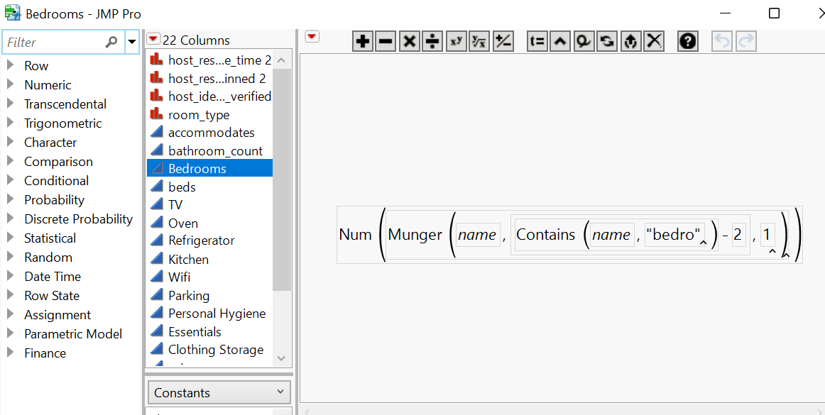

*Figure 2.1: Screenshot of Bedrooms Formula*

**Amenities as Indicator Columns** - In order to extract data useful information from the amenities column for price prediction, we had to create indicator columns by creating a unique formula for each column which “indicated” if the column contained that grouped or ungrouped item. For example in the column labeled “TV”, the rows that had a 1 contained the values “TV” in each row. The rows that had a 0 did not contain any values with “TV” in them. The screenshot of the formula used to achieve this task is attached below.

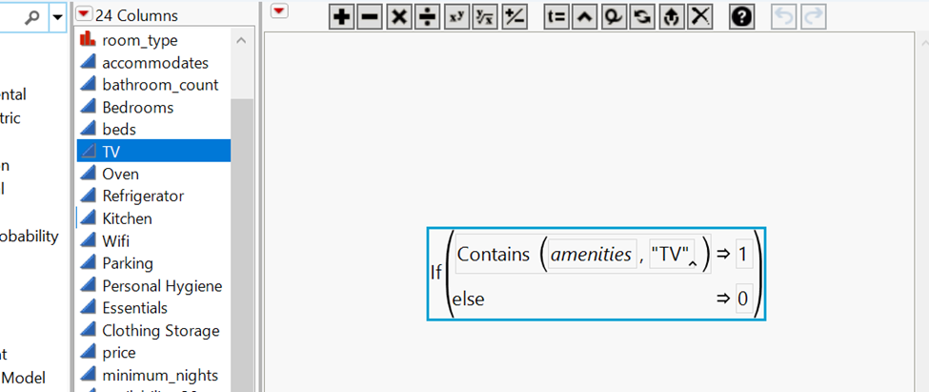

*Figure 2.2: Screenshot of Amenities Indicator Formula*

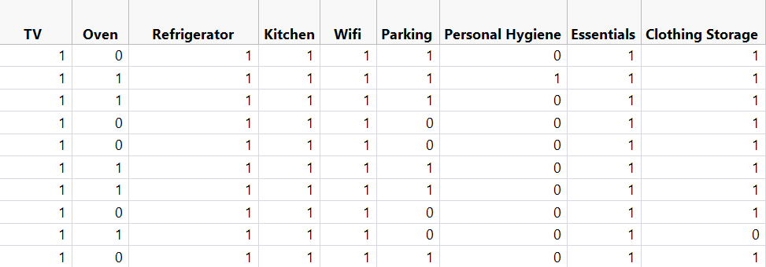

*Figure 2.3: Screenshot of Amenities Indicator Cols*

**Bathrooms:** Since the original ‘bathrooms’ column has no data to be used, we decided to extract bathroom count information from the ‘bathrooms_text’ column and create a new ‘Bathrooms_count’ column.. We used the ‘Text to Column’ utility to achieve this task.The screen shot of the extracted column is attached below.

**Delimiter used: ‘ ‘**

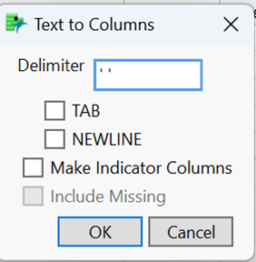

*Figure 2.4: Screenshot of Delimiter*

**host_response_time:** There are 3004 ‘N/A’ values in the ‘host_response_time’ column, which are recoded into missing values. ‘Host_response_time’ is the newly recoded column.

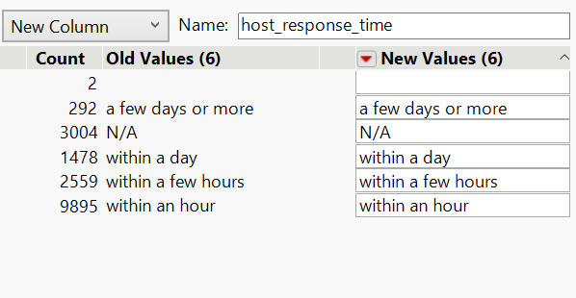

*Figure 2.5: Screenshot of Recode*

**After performing these modifications now we have 21 columns in total and worked upon in later sections.**

Ø Host_response_time

Ø host_identity_verified

Ø neighbourhood_cleansed

Ø room_type

Ø accommodates

Ø Bathrooms_count

Ø Bedrooms

Ø beds

Ø TV

Ø Oven

Ø Refrigerator

Ø Kitchen

Ø Wifi

Ø Parking

Ø Personal Hygiene

Ø Essentials

Ø Clothing Storage

Ø price

Ø availability_30

Ø review_scores_rating

Ø instant_bookable

C**. Missing Values**

**Explore Missing Values:**

We attached the screenshot showing missing records in each column after performing the ‘Explore Missing Values’ analysis.

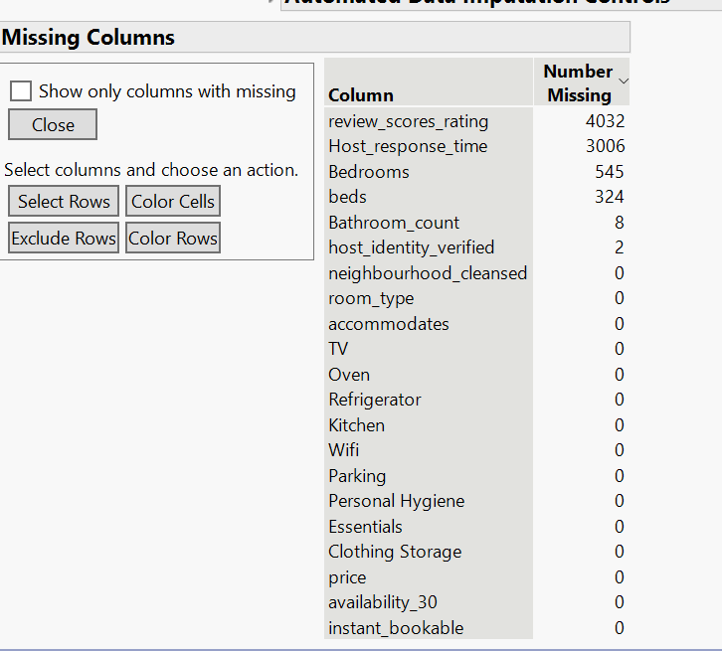

*Figure 2.3.4: Screenshot of Missing Records in Columns*

From the above table we can see that there are a considerable number of missing values in review_scores_rating and Host_response_time columns. Since, Imputation of huge data in a single column doesn’t help to build an accurate model, we tried to get the missing data pattern and exclude the records with missing variables.

**Missing Data Pattern:**

The below screenshot shows the count and pattern of missing data in all the records. The highlighted records are excluded and hidden from the data set.

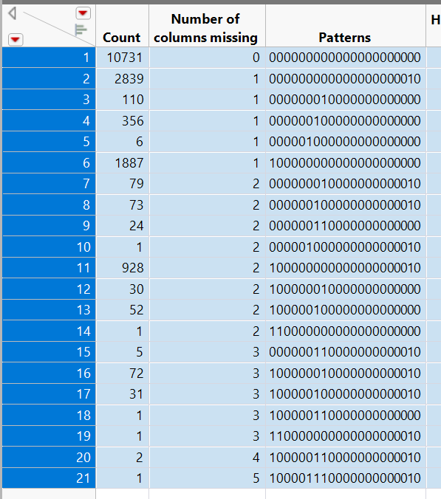

*Figure 2.3.5: Screenshot of Missing Data Pattern*

**D. Outliers**

**Univariate Outliers:** Below screenshot shows the summary of univariate outliers in each column after performing ‘Explore Outliers’ analysis

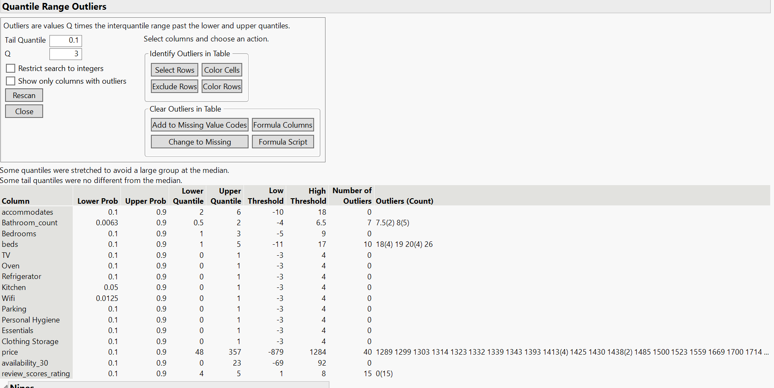

*Figure 2.4.1: Screenshot of the summary of outliers identified*

The outliers in Bathroom_count,Bedrooms,price and review_scores_rating columns are identified and taken care of in the below sections

***Bathroom_count:***

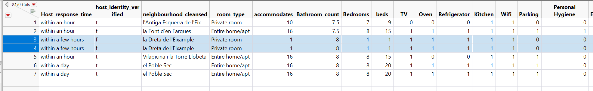

*Figure 2.4.2: Screenshot of the summary of Bathroom_count*

From the above screenshot we can see that there are 7 outliers in the column. After analyzing, we identified Bathroom_count=8 as a potential outlier and decided to exclude the highlighted 2 records in the image 2.4.2 because it’s not practically possible for a room with 1 bedroom and can accommodate only 1 person to have 8 bathrooms. Hence excluded the highlighted 2 rows in the image 2.4.2.

***Beds:***

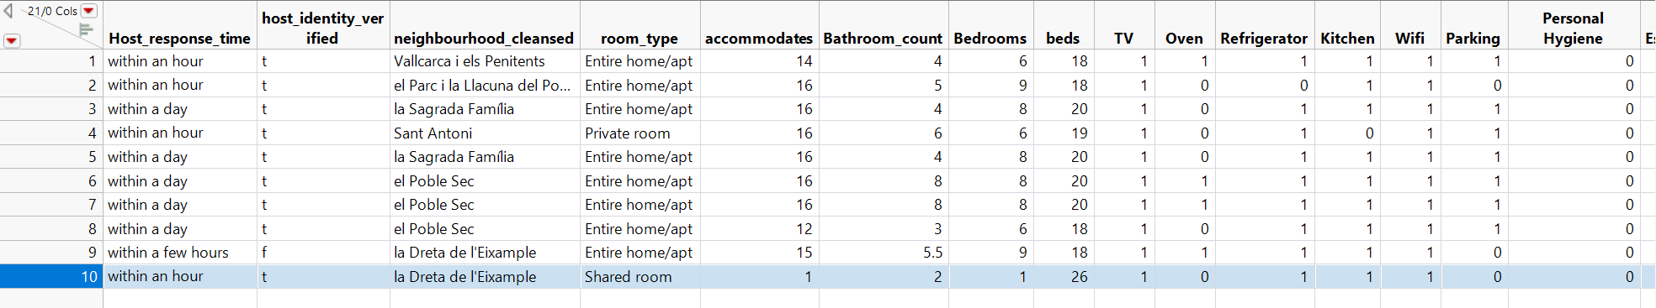

*Figure 2.4.3: Screenshot of the summary of Beds*

There are 10 outliers in beds column. After analyzing, we identified 26 beds as a potential outlier and decided to exclude the highlighted record in the image 2.4.3 because it’s not practically possible for a room with 1 bedroom and can accommodate only 1 person to have 26 beds. Hence excluded the highlighted 2 rows in the image 2.4.2.

**Price:** Price variable values are not considered as outliers because it is our target variable where we consider the given value of the data according to the other requirements of the variables.

**review_score_rating:** The outliers shown in the screenshot 2.4.1 are considered because the review score rating of those 15 rows is 0 which states that there are no reviews for those 15 Airbnb’s but they can be priced considering the other features.

**Multivariate outliers:**

Once we handle univariate outliers, multivariate outlier analysis is performed using’Mahalanobis Distance’ to identify potential multivariate outliers and exclude them.

*Figure 2.4.4: Screenshot of Mahalanobis Distances*

**E. Reducing dimensionality**

**To reduce the We decided to do ‘Principal Component Analysis’ on the columns**

Ø TV

Ø Oven

Ø Refrigerator

Ø Kitchen

Ø Wifi

Ø Parking

Ø Personal Hygiene

Ø Essentials

Ø Clothing Storage

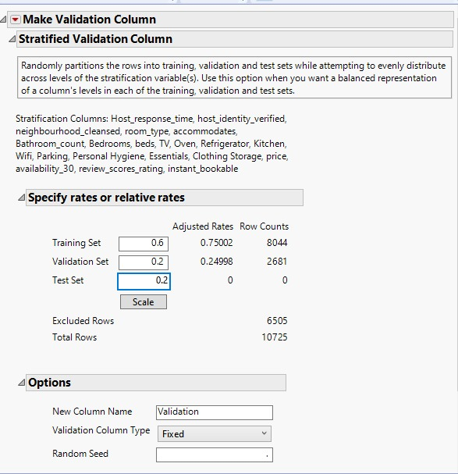

# 5. Conclusion

The initial Barcelona, Catalonia, Spain Airbnb data set contains **17230 rows x 75 columns**. Through data preprocessing, we excluded and hid 6502 rows and ??? columns, the data set has been cleansed and reduced to **17230 rows x 22 columns.**

The same has been achieved by reducing data dimensionality, excluding the missing values, detaching and smoothening the outliers, which will have an impact on the target variable, and lastly addressing outliers.